Seven segment display

Seven segment display consists of 7 LED segments (a,b,c,d,e,f,g,) along with a optional decimal point (h or dp).

There are two types of LED 7-segment displays: common cathode (CC) and common anode (CA). The difference between the two displays is the common cathode has all the cathodes of the 7-segments connected directly together and the common anode has all the anodes of the 7-segments connected together. Shown below is a common anode seven segment.
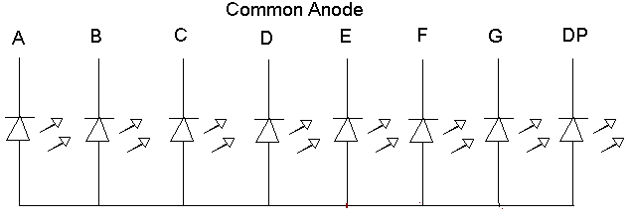
As shown above all the anode segments are connected together. When working with a common anode seven segment display, power must be applied externally to the anode connection that is common to all the segments usually high voltage. Then by applying a ground to a particular segment connection (a-g), the appropriate segment will light up.

A common cathode seven segment is different from a common anode segment in that the cathodes of all the LEDs are connected together. For the use of this seven segment the common cathode connection must be grounded and power must be applied to appropriate segment in order to illuminate that segment.
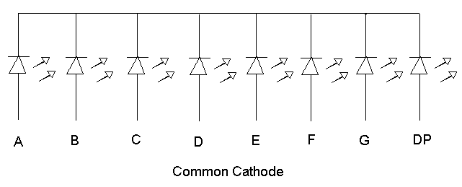

The table shows the seven segment codes of number 0 to 9.

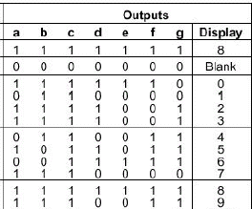

Interfacing

The figure shows the interfacing of a seven segment display and simple 8 key keyboard using a 8255. Port A is the input port and port B is the output port. The keys k7-k0 is tied high through 10k resistors, and when a key is pressed, the corresponding line is grounded. When all keys are open and if 8085 reads port A, the reading on the data bus will be FFH. When any key is pressed, the reading will be less than FFH. For example,, if k7 is pressed, the output of port A will be 01111111(7FH). This reading should be encoded into the binary equivalent of the digit 7 by using software routines.
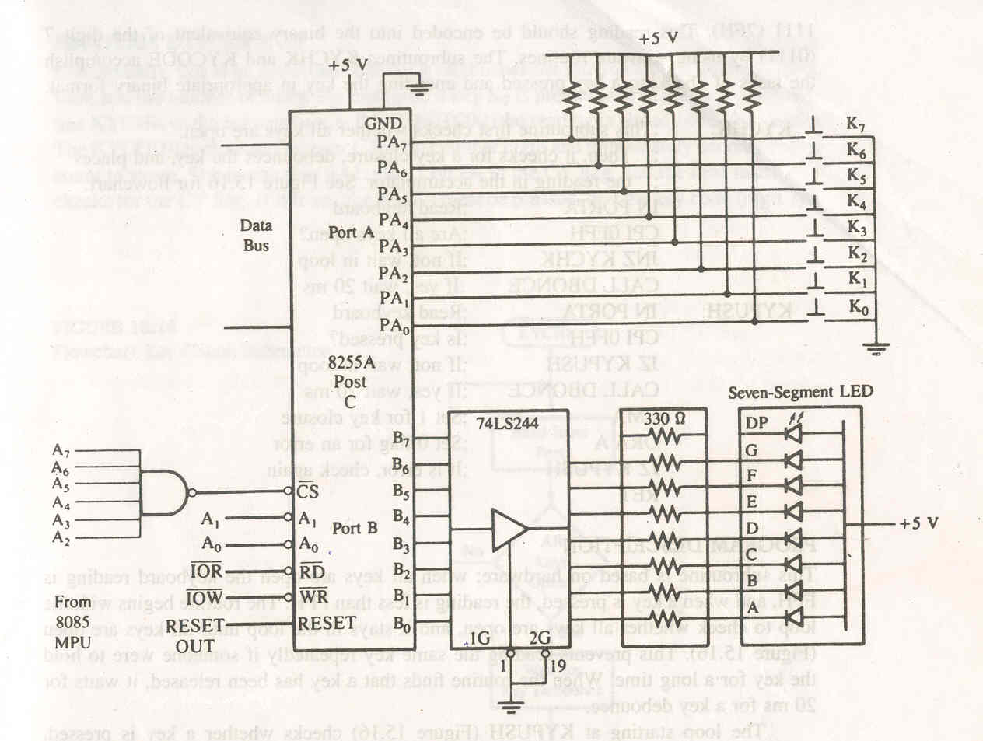

The figure also shows that a common anode seven segment LED is connected to port B through driver 74LS244. The driver is necessary to increase the current capacity of port B; each LED segment requires 15-20 mA of current. The driver is an octal non inverting driver with tri-state output and current sinking capacity of 24 mA. It has two active low enable line (1G’ and 2G’), and the driver is permanently enabled by grounding these lines.

To display the number of the key pressed, a routine is necessary that will send an appropriate code to port B. The routine will supply the binary number of the key pressed; however, there is no relationship between the binary value of a digit and its seven segment code. Therefore, the table look up technique will have to be used to find the code for the digit supplied by the routine.

Matrix keyboard

A matrix keyboard is a commonly used input device when more than eight keys are necessary, rather than rows of keys. A matrix keyboard reduces the number of connections, thus number of interfacing devices required. Interfacing a matrix keyboard requires two ports: one output port and other input port. Rows are connected to the output port, and columns are connected to input port.
In a matrix keyboard, the major task is to identify a key that is pressed and decode the key in terms of its binary value.

Interfacing (Software approach)

Figure shows a matrix keyboard with 20 keys; the keyboard has 5 rows and 4 columns. The first 16 keys in a sequence will represent data 0 to F in Hex and the remaining 4 keys will represent various functions such as store and execute. The circuit shows that the rows are connected to port C and the columns to port B of 8255A.

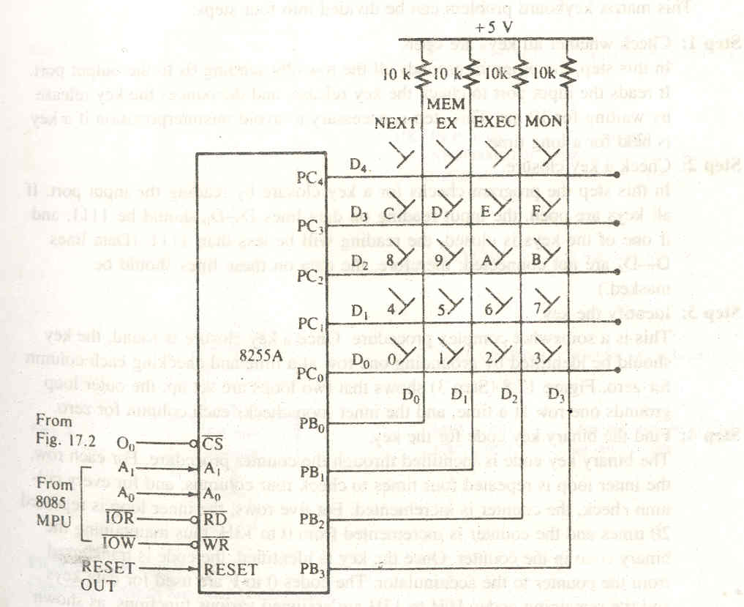
The columns and rows make a contact only when a key is pressed, otherwise, they remain high (+5v). When a key is pressed, the key must be identified by its columns and the row; the intersection of the column and row changes from high to low. This can be accomplished as in the following steps.

- Ground all rows by sending logic 0 through the output port.
- Check the columns by reading the input port. If no key is pressed, all columns remain high. Continue to repeat steps 1 and 2 until the reading indicates a change.
- When one of the keys is pressed, the corresponding column goes low; identify and decode the key.

Flowchart

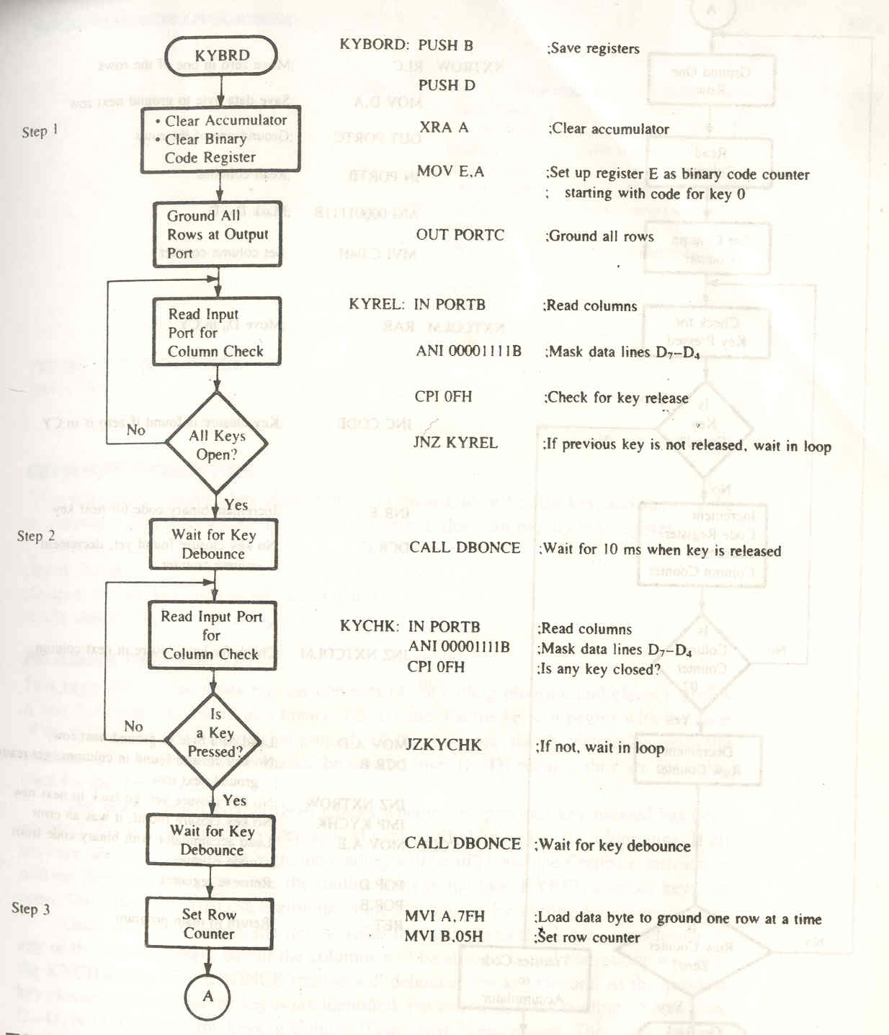
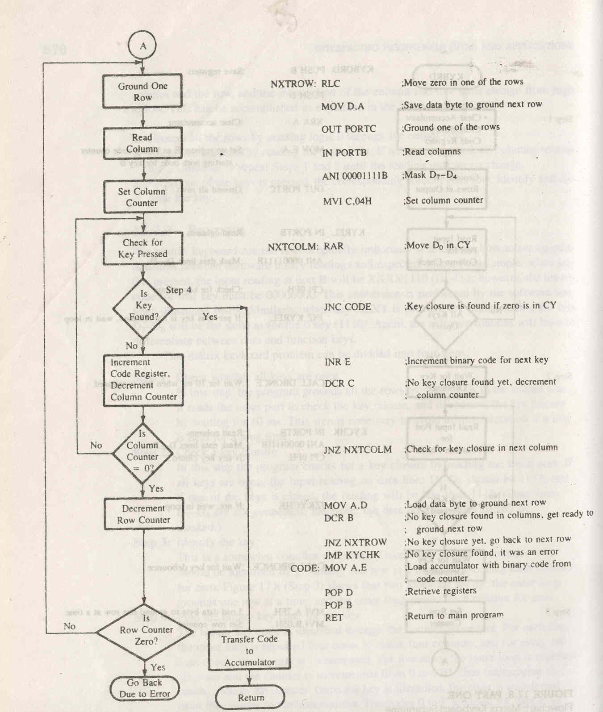

The matrix keyboard problem can be divided into 4 steps:

- Check whether all keys are open

In this step, the program grounds all the rows by sending 0s to the output port. It reads input port to check the key release, and denounces the key release by waiting for 10 ms.

- Check Key closure

In this step, the program checks for a key closure by reading the input port. If all keys are open, the input reading on data lines D3 - D0 should be 1111, and if one of the keys is closed, the reading will be less than 1111.

- Identify the key

Once a key closure is found, the key should be identified by grounding one row at a time and checking each column for zero. Figure shows that 2 loops are set up: output loop grounds one row at a time; and inner loop checks each column for zero.

- Find binary key code for key

The binary key code is identified through the counter procedure. For each row, the inner lop is repeated four times to check four columns, and for every column check, the counter in incremented. For 5 rows, the inner loop is repeated 20 times and counter is incremented from 0 to 13 H, thus maintaining the binary code in the counter. Once the key is identified, the code is transferred from the counter to the accumulator.

HARDWARE FOR 8 x 8 MATRIX KEYBOARD INTERFACE

In a hardware approach, 8279 is used as the interface. The scanning operation is done by 8279 and CPU is free to perform other operation. When a key press is detected, CPU is interrupted to inform about the key press. Then the CPU reads the FIFO RAM.

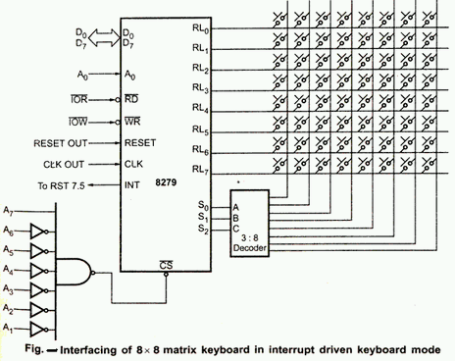

FLOWCHART

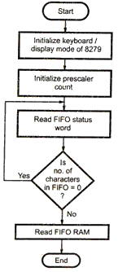

Debounce

When a push button key is pressed, it bounces (makes and breaks contact) a few times before it makes a firm contact. To prevent multiple readings of the same key, it is necessary to Debounce the key.
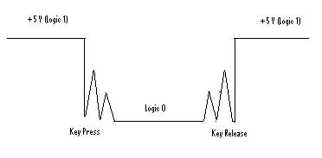

Two approach.

- Software approach: It is to wait for 10 to 20 ms until key settles and then check the key again.
- Hardware approach: This has a key Debounce circuit (cross coupled NAND or NOR gates.
When mechanical push down key is pressed or released, the metal contact of the key momentarily bounces before giving a steady state reading. Therefore it is necessary that the key should not be read as an input. The key bounce can be eliminated from input data by the key Debounce circuit.
In this circuit, the outputs of the NAND gets do not change even if the key is released from position A1. The output change when the key makes contact with position B1. When a key is connected to A1, A1 goes low. If one of the input of the NAND gate G1 is low, the output O1 becomes high, which makes B2 high. Because B1 is already high, the output O2 goes low which makes A2 low. When the key connection is released from A1, it goes high, but because A2 is low the output doesn’t change. When key comes in contact with B1, the output changes. This means when key goes from one contact to another, output doe not change during the transition period thus eliminating multiple reading.

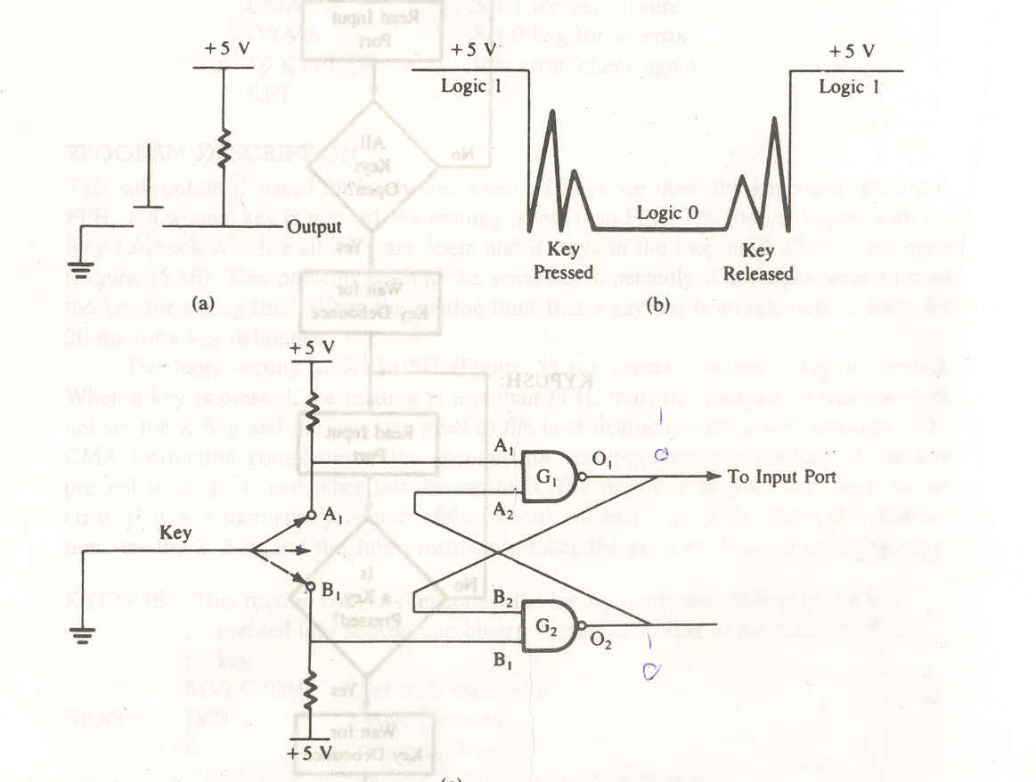
Analog to Digital Converters

The ADC is treated as input device by the microprocessor that sends an initializing signal to the ADC to start the analog to digital data conversion process. The start of conversion (SOC) signal is a pulse of specific duration. After the conversion is over, the ADC sends end of conversion (EOC) signal to inform the microprocessor that conversion is over and the result is ready at the output buffer of the ADC. These tasks of issuing an SOC pulse to ADC, reading EOC signal from the ADC and reading the digital output of the ADC are carried out by the CPU using 8255 I/O ports.

The time taken by the ADC from the active edge of SOC pulse (the edge at which the conversion process actually starts) till active edge of EOC signal is called as the conversion delay of the ADC.

A general algorithm for ADC interfacing contains the following steps.

- Ensure the stability of analog signal, applied to ADC.
- Issue SOC pulse to ADC.
- Read EOC signal to mark the end of conversion.
- Read the digital data output of the ADC as equivalent digital output.

Analog input voltage must be constant at the input of the ADC right from the start of conversion till the end of the conversion to get correct results. This may be ensured by a
sample and hold circuit which samples the analog signal and holds it constant for specific time duration. The microprocessor may issue a hold signal to the sample and hold circuit. If the applied input changes before the complete conversion process is over, the digital equivalent of the analog input calculated by the ADC may not be correct.

ADC 0808/0809

The ADC chip 0808 and 0809 are 8 bit CMOS, successive approximation converters. Successive approximation technique is one of the fast techniques for analog to digital conversion. These converters internally have a 3:8 analog multiplexer so that at a time 8 different analog inputs can be connected to the chips. Out of these 8 inputs only one can be selected for conversion using address lines ADD A, B, C.

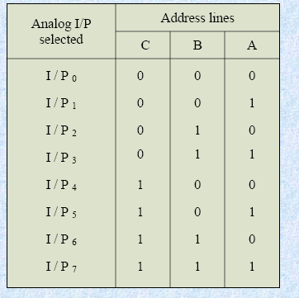

These are unipolar ADC, i.e. they are able to convert only positive analog input voltage to their digital equivalents. These chips do not contain any internal sample and hold circuit. If one needs a sample and hold circuit for conversion of fast signals into equivalent digital quantities, it has to be externally connected at each of the analog input.
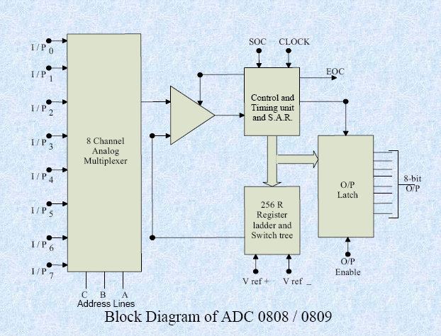
Pin description

- I/P0 – I/P7: Analog input.
- ADD A, B, C: Address lines for selecting analog inputs.
- O7 – O0: Digital 8 bit output with O7 as MSB and O0 as LSB.
- SOC: Start of conversion pin.
- EOC: End of conversion signal pin.
- CLK: Clock input for ADC.
- OE: Output latch enable pin, if high enables output.
- Vcc, GND: Supply pins +5V and GND.
- Vref+ and Vref- : Reference voltage positive (+5 V max) and negative ( 0V minimum)

Interfacing of ADC 0808

Figure shows the interfacing connections of ADC 0808 using 8255. The analog input I/p2 is used and therefore address pins A, B, C should be 0, 1, and 0 respectively to select I/P2. The OE and ALE pins are already kept at +5V to select the ADC and enable the output. Port C upper acts as the input port to receive the EOC signal while port C lower acts as the output to send SOC to the ADC. Port A acts as an 8 bit input data port to receive the digital data output form the ADC.

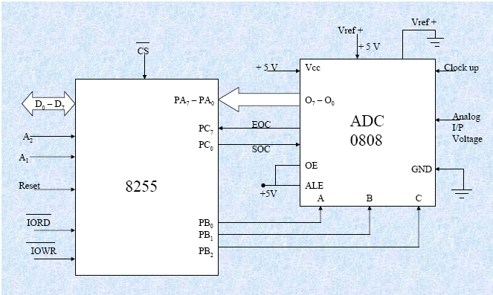

Interfacing Digital to Analog Converters

The digital to analog converters convert binary number into their equivalent voltages. The DAC find applications in areas like digitally controlled gains, motors speed controls,
programmable gain amplifiers etc.

AD 7523 8-bit Multiplying DAC

This is a 16 pin DIP, multiplying digital to analog converter, containing R-2R ladder for D-A conversion along with single pole double thrown NMOS switches to connect the digital inputs to the ladder.

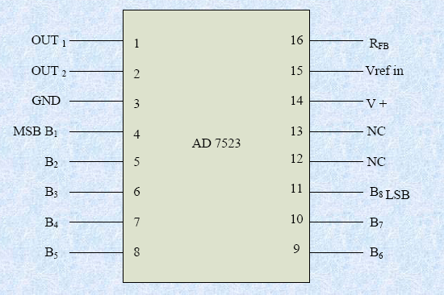

The pin diagram of AD7523 is shown in fig the supply range is from +5V to +15V, while Vref may be any where between -10V to +10 V. The maximum analog output voltage will be any where between -10V to + 10V, when all the digital inputs are at logic high state. Usually a zener is connected between OUT1 and OUT2 to save the DAC from negative transients. An operational amplifier is used as a current to voltage converter at the output of AD to convert the current out put of AD to a proportional output voltage. It also offers additional drive capability to the DAC output. An external feedback resistor acts to control the gain. One may not connect any external feedback resistor, if no gain
control is required.

Interfacing DAC AD7523

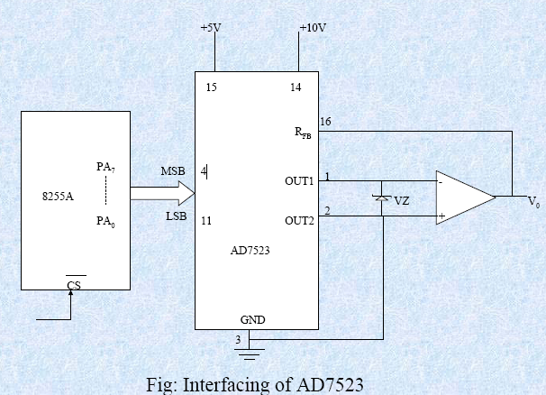

In the above program, port A is initialized as the output port for sending the digital data as input to DAC. The ramp starts from the 0V (analog), hence AL starts with 00H. To increment the ramp, the content of AL is increased during reach execution of loop till it reaches F2H. After that the saw tooth wave again starts from 00H, i.e. 0V (analog) and the procedure is repeated. The ramp period given by this program is precisely 1.000625 ms. Here the count F2H has been calculated by dividing the required delay of 1ms by the time required for the execution of the loop once. The ramp slope can be controlled by calling a controllable delay after the OUT instruction.

Microcontrollers

Microcontrollers are hidden inside a surprising number of products these days. If your microwave oven has an LED or LCD screen and a keypad, it contains a microcontroller. All modern automobiles contain at least one microcontroller, and can have as many as six or seven: The engine is controlled by a microcontroller, as are the anti-lock brakes, the cruise control and so on. Any device that has a remote control almost certainly contains a microcontroller: TVs, VCRs and high-end stereo systems all fall into this category. Nice SLR and digital cameras, cell phones, camcorders, answering machines, laser printers, telephones (the ones with caller ID, 20-number memory, etc.), pagers, and feature-laden refrigerators, dishwashers, washers and dryers (the ones with displays and keypads) has microcontroller in it.
Microcontrollers are "special purpose computers." Microcontrollers do one thing well. There are a number of other common characteristics that define microcontrollers. If a computer matches a majority of these characteristics, then you can call it a "microcontroller":
- Microcontrollers are "embedded" inside some other device (often a consumer product) so that they can control the features or actions of the product. Another name for a microcontroller, therefore, is "embedded controller."
- Microcontrollers are dedicated to one task and run one specific program. The program is stored in ROM (read-only memory) and generally does not change.
- Microcontrollers are often low-power devices. A desktop computer is almost always plugged into a wall socket and might consume 50 watts of electricity. A battery-operated microcontroller might consume 50 milliwatts.
- A microcontroller has a dedicated input device and often (but not always) has a small LED or LCD display for output. A microcontroller also takes input from the device it is controlling and controls the device by sending signals to different components in the device.
For example, the microcontroller inside a TV takes input from the remote control and displays output on the TV screen. The controller controls the channel selector, the speaker system and certain adjustments on the picture tube electronics such as tint and brightness. The engine controller in a car takes input from sensors such as the oxygen and knock sensors and controls things like fuel mix and spark plug timing. A microwave oven controller takes input from a keypad, displays output on an LCD display and controls a relay that turns the microwave generator on and off.
- A microcontroller is often small and low cost. The components are chosen to minimize size and to be as inexpensive as possible.

Basic introduction to the 8051 microcontroller

The 8051 is an 8-bit microprocessor originally designed in the 1980's by Intel that has gained great popularity since its introduction. Its standard form includes several standard on-chip peripherals, including timers, counters, and UART's, plus 4kbytes of on-chip program memory and 128 bytes (note: bytes, not Kbytes) of data memory, making single-chip implementations possible. Its hundreds of derivatives, manufactured by several different companies (like Philips) include even more on-chip peripherals, such as analog-digital converters, pulse-width modulators, I2C bus interfaces, etc. Costing only a few dollars per IC, the 8051 is estimated to be used in a large percentage (maybe 1/2?) all embedded system products.

The 8051 memory architecture includes 128 bytes of data memory that are accessible directly by its instructions. A 32-byte segment of this 128 byte memory block is bit addressable by a subset of the 8051 instructions, namely the bit-instructions. External memory of up to 64 Kbytes is accessable by a special "movx" instruction. Up to 4 Kbytes of program instructions can be stored in the internal memory of the 8051, or the 8051 can be configured to use up to 64 Kbytes of external program memory The majority of the 8051's instructions are executed within 12 clock cycles.

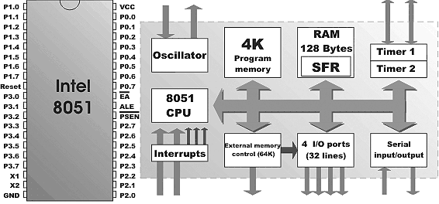
As can be seen on the image above, there is nothing particularly remarkable about MCU 8051:
- 4 kilobytes of ROM is neither too little nor too much.
- 128 bytes of RAM (SFR registers included) can satisfy the basic needs, but is not really astounding.
4 ports totaling 32 I/O lines, are usually sufficient for connecting to the environs and are by no means luxury.
Obviously, 8051 configuration is intended to satisfy the needs of programmers developing the controlling devices and instruments. This is one part of its key to success: there is nothing missing, yet there is no lavishness; it is meant for the average user. The other clue can be found in the organization of RAM, Central Processor Unit (CPU), and ports - all of which maximally utilize the available resources and allow further upgrades.

